HealthCheck Social Media Content
Below is HealthCheck content you can post on your Facebook and Twitter pages.
You can also follow and share Wisconsin Department of Health Services (DHS) posts on social media:
- Facebook: Follow DHS on Facebook and share HealthCheck posts you see to your organization’s Facebook page.
- Twitter: Follow WIDeptHealthServices (@DHSWI) on Twitter and retweet HealthCheck posts.

Example Facebook posts
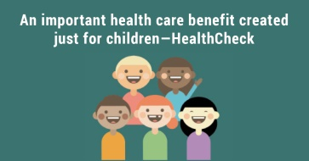
Did you know? There is an important Medicaid benefit called #HealthCheck that covers your child’s annual exams and specialized services. It helps prevent illnesses and find and treat health issues early. Anyone under 21 who has Medicaid, BadgerCare Plus, or a ForwardHealth card is automatically covered. Learn more: dhs.wisconsin.gov/healthcheck

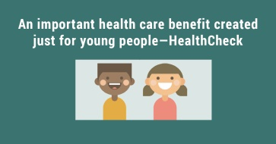
Did you know? #HealthCheck is a Medicaid benefit especially created for young people. Anyone under 21 who has Medicaid, BadgerCare Plus, or a ForwardHealth card is automatically covered. You get in-depth exams and checkups. You also get specialized services or products that may be needed. There are no forms to fill out. All you need to do is call your doctor and make an appointment for a HealthCheck exam. Learn more: dhs.wisconsin.gov/healthcheck
Instructions
Image: Download these images to your computer:
- Right click on the image.
- Choose Save as Picture from the drop-down menu.
- Name the image and save it as a .jpg file on your computer.
- Upload the image from your computer into a Facebook post.
Text: Copy and paste the language into your Facebook post.

Example Twitter tweets (You can also use these for Facebook)
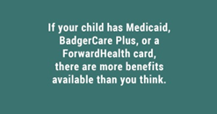
Don’t miss out on this important Medicaid benefit called #HealthCheck. It covers your child’s annual exams and specialized services just by using your ForwardHealth card. Learn more: dhs.wisconsin.gov/healthcheck
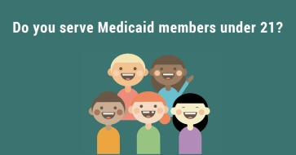
Help us spread the word about #HealthCheck—a valuable, preventive Medicaid health care benefit for your patients. HealthCheck covers in-depth exams and specialized services or products to address medical, dental, vision, and hearing needs. Learn more: dhs.wisconsin.gov/healthcheck

Instructions
Image: Download these images to your computer:
- Right click on the image.
- Choose Save as Picture from the drop-down menu.
- Name the image and save it as a .jpg file on your computer.
- Upload the image from your computer into a Twitter post.
Text: Copy and paste the language into your Twitter post.

